16

**Content Projection**

* What is Content Projection?
* Implementations of Content Projection
  + Single slot
  + Multi-slot
  + Conditional
* Ng-container Vs Ng-Template

**What is Content Projection?**

* Content projection is a method of importing HTML content from outside a component and inserting it into the component's template in certain content.
* Content projection allows a directive to use templates while still being able to clone the original content and add it to the DOM, which is a programming interface for HTML and XML documents and represents a page where programs can change the document structure, style, and content.

**Single-slot Content Projection**

* The term single-slot content projection refers to the creation of a component into which only one component can be projected.

Example – Child Component

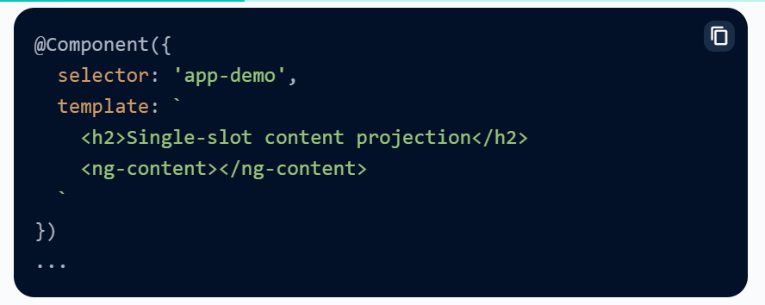

Parent Component

**Multi-slot Content Projection**

* A component may have several slots.
* Each slot can have its own CSS selector that specifies what content gets into it.
* Multi-slot content projection is the name given to this pattern.
* You must indicate where you want the projected content to appear using this pattern.
* This is accomplished by utilizing the select property of <ng-content>.

Example-

Child Component

Parent –

Here, one of the <ng-content> contains select="[heading]. i.e. it will only project the data which contains the heading attribute.

### Conditional Content Projection

* If your component has to conditionally render content or render content several times, you should set it up to accept a <ng-template> element containing the conditionally rendered content.
* It is not suggested to utilize a <ng-content> element in these circumstances because when a component's consumer delivers the content, the content is always initialized, even if the component does not specify a <ng-content> element or if that <ng-content> element is inside of a ngIf statement.
* You may have your component directly render content based on any condition you want, as many times as you like, using a <ng-template> element. Angular will not render a <ng-template> element's content unless it is expressly rendered.

Example –

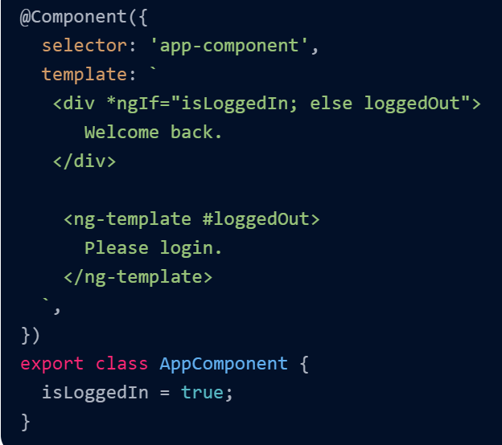

Here **<ng-template>** will render only when the condition failed.

**Ng-Container Vs Ng-Template**

|  |  |
| --- | --- |
| **Ng-Content** | **Ng-Template** |
| * ng-container will serve as a container for elements, It will accept structural directives like ngFor, ngIf etc. But it will never get rendered to the DOM. | * ng-template allows us to create template content, this also will not render to the DOM until we specifically/conditionally add it to the DOM. |

ALL THE BEST